Title or Task: | Title  

Description:

Files Required
Suitable for Classes: | All classes
Area: | Technology & Enterprise
Teacher: | Mr Peter Faulks

Timeline

Date Due:

Task Brief:

Outcomes:

Items highlighted in yellow are tasks for you to complete
Items in Blue italics are help tips

Worksheet

Fairmont Hotel

Background
• Working on a 4 page brochure for a hotel.
• Photographs taken with digital camera.
• Moving away from designing compositions in Photoshop and placing on page to designing in InDesign.
• Take the job right through to output.
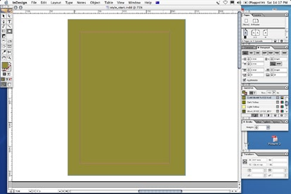
Page 1:
1. InDesign – Open “00_Start.indd”
2. Setup Layers > add 3 extra layers >
- Document Background
- Element Images
- Element Text
3. Go to Photoshop >Browse to the Kodak Folder
4. In Photoshop bring in each image and rotate photos to suit.
(I have done this for you)

5. Save all photos as .psd and a copy as a .jpg using the same name.

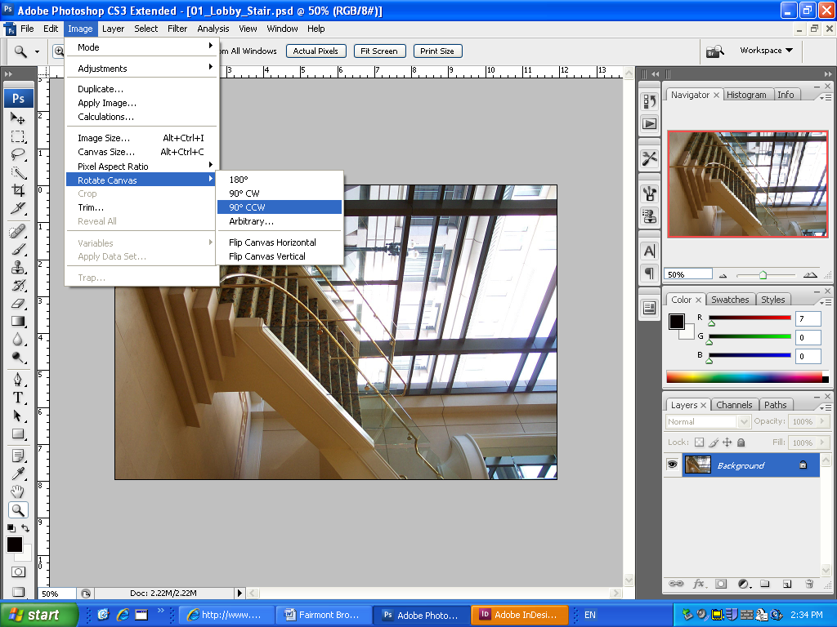

Start Composting

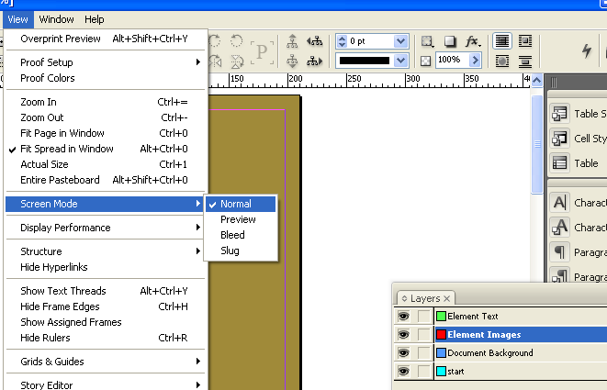
- Return to InDesign in View Screen Mode = Normal

2. I n Background layer place a SOLID BOX with
FILL C=44 M=44 Y=100 K=0

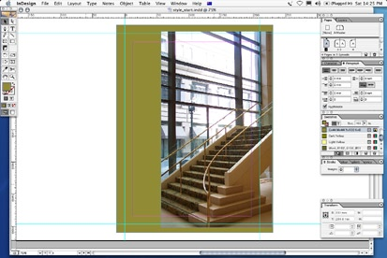
3. On layer Element Images Place LOBBY_STAIRS image
onto side of the page then drag into page and re size image
with BLEED (The part outside of the red page indicator (margin))

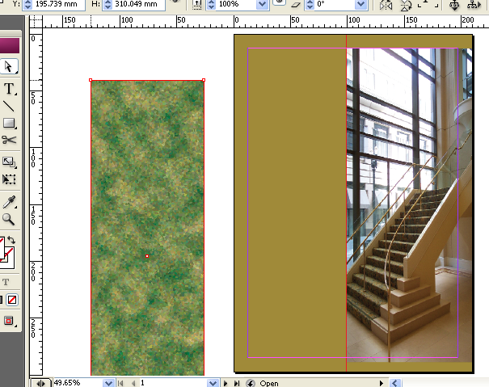
4. Place Photoshop_Pattern (original green) into document (at the side then drag onto work LEFT HAND SIDE,

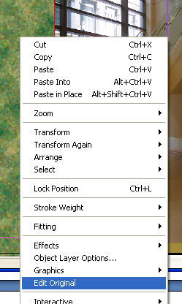
Note: it LOOKS BAD
5. Right click, EDIT ORIGINAL on pattern. Or Open and change in Photoshop

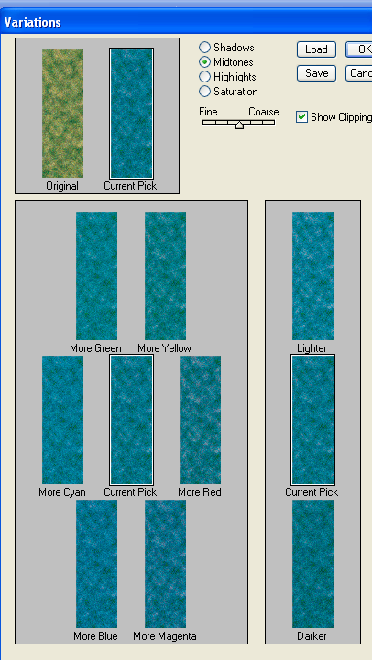
6. Use Image Adjustments Variations to change the colour to blue

7. Save the pattern, as water patern.psd and then return to InDesign
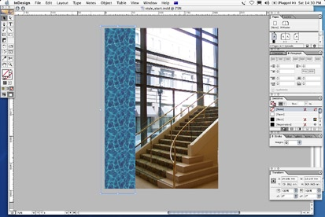

8. Select the picture of the stairs, and start playing with the BLENDING MODES in InDesign – we are now DESIGNING in InDesign. Select HARD LIGHT
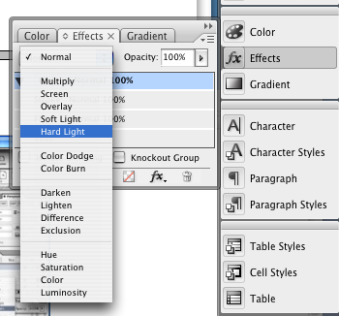
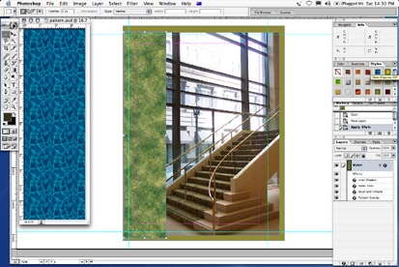
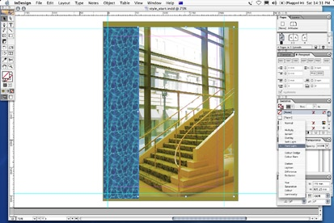

9. Place some more pictures on the page, (Use lobby shots)
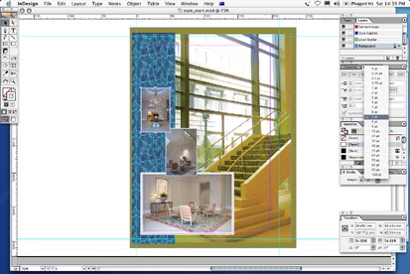

01_Lobby_Chair.jpg
01_Lobby_Rest.jpg
01_Lobby_Vase.jpg

10. Arrange as small postcard shots add, white border
11. Add Drop Shadow
12. Add a text box down the right hand side
13. Drop some dummy text in as a place holder
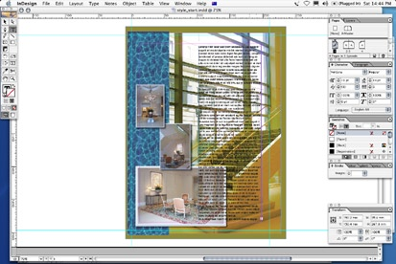
14. Add box behind, fill with White and set overlay / transparency

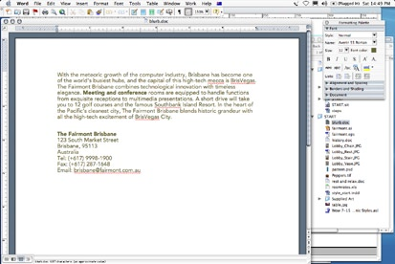
15. Find MICROSOFT word doc,
(blurb.doc) and OPEN IN WORD

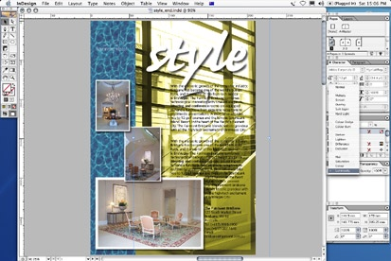
16. Return to InDesign import word document, in place of DUMMY text.

Page 2

1. Navigate to PAGE 2.
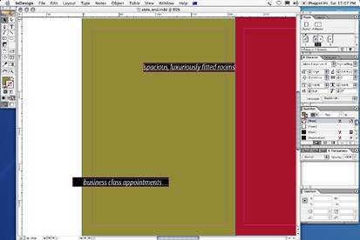
2. Drop 2 square text boxes in TOP LEFT and BOTTOM RIGHT corners of page (put on the TEXT LAYER)
3. Select TOP left text box and place WORD doc, “rest and relax” into it.

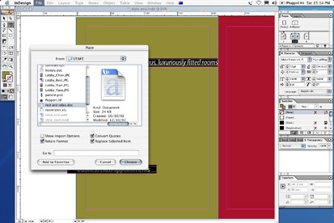
4. Note there is too much text for that BOX (little red BOX)

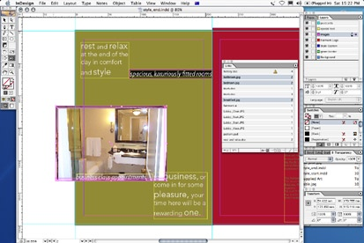
5. Click on little red box and link Text box 1 to Text Box 2, demonstrate TEXT flow.
6. Import Pictures 1 + 2 + 3 into the 3 spaces (TOP RIGHT, MIDDLE and BOTTOM LEFT) Make sure you put them on the images layer.

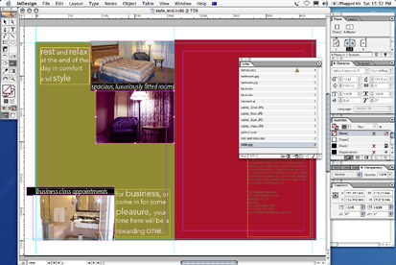
7. When you place the MIDDLE image, USE TABLE.JPG

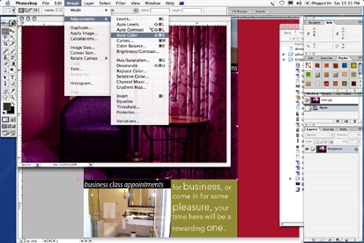
8. Note the image is TOO RED, should be obvious
9. Take back to PS7 and USE AUTOCOLOR to fix.

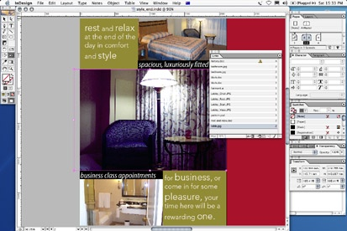
10. Simplicity of workflow between image correction and placement. Click back in InDesign for automatic update.

Page 3
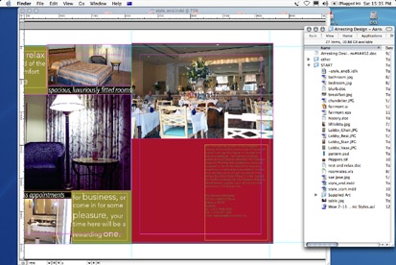
1. Import picture of BREAKFAST buffet.
2. Place TOP HALF of document (on top of red background)

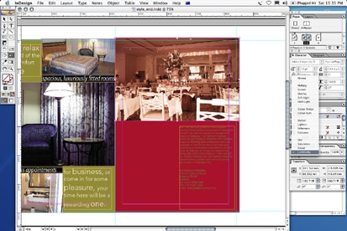
3. Again, play with BLENDING MODE, choose LUMINOSITY
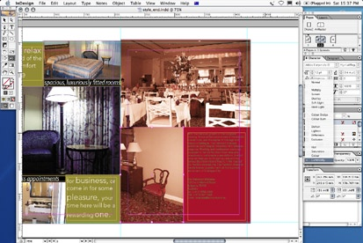
4. Do same for second pic of CHAIR. Place in bottom left. Aside the existing text.

5. Locate the excel document…. Roomrates.xls
6. Open the document in EXCEL

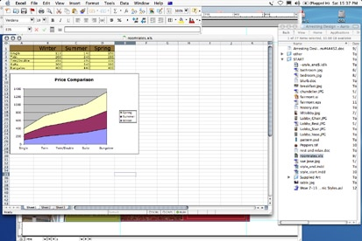
7. Return to InDesign, and place the EXCEL document on PAGE 3
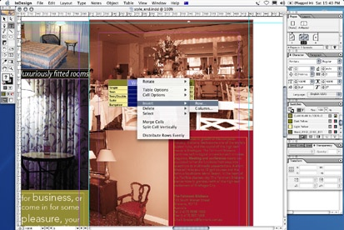
8. In InDesign, Edit the chart by adding an extra Column with the text tool

9. Insert a NEW HEADER alongside SUMMER, called “Special”
10. Insert SPECIAL rates for each corresponding bedroom,
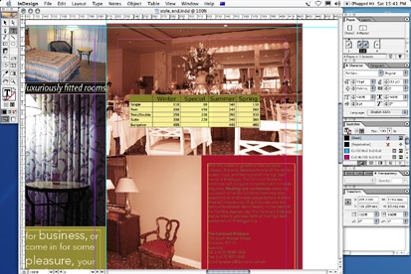
11 Move table around the page, and add a Dropshadow
12. Apply WRAP property to table and move over text

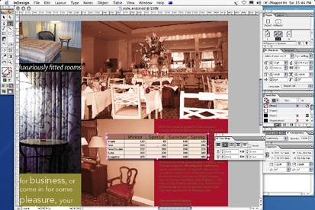
13. Apply LUMINOSITY to TABLE demonstrate transparency on live EXCEL document.

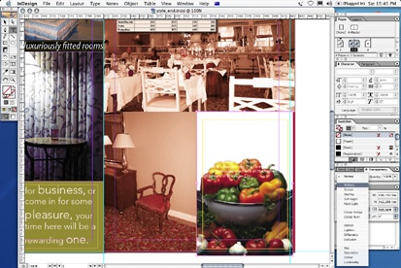
14. Import PICTURE, peppers.tif,

RESIZE to SAME size as TEXT BOX, (or RED BOX BEHIND TEXT BOX)

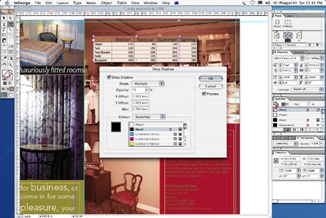

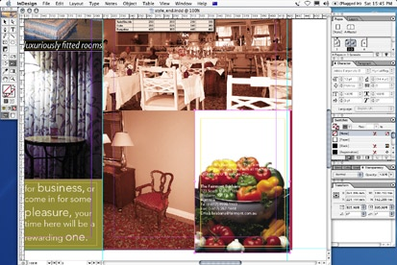
15. Use the OBJECT menu>Clipping Path>Detect Edges tool to automatically create a clipping path

16. Set BLENDING MODE TO difference

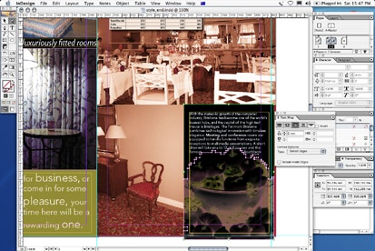

17. Set WRAP property to WRAP around object (the little circle icon in wrap palette and explore choices)

Page 4
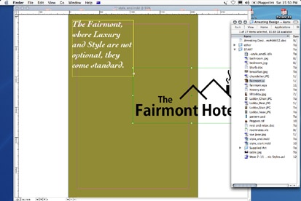
1. Import Illustrator LOGO (Fairmont.ai), into layout

2. Talk about ILLUSTRATOR files actually being PDF files.
3. Right click logo and EDIT in Illustrator
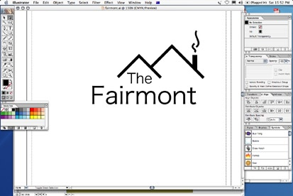

4. Make a small change as shown and return, show auto update
5. Zoom in on LOGO and point out InDesign DISPLAY setting preferences.
6. Switch from Optimised to High Quality while zoomed and point out difference, explain accuracy (AGM) and 4000% zoom.

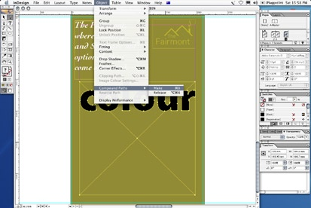
7. Zoom back out to full size.
8. Now type some text in BOLD FAT typeface

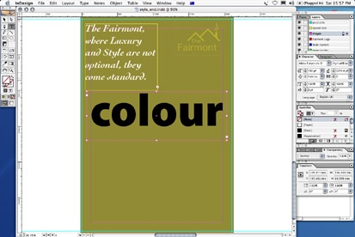

9. Example “colour”
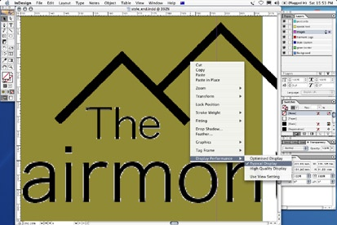
10. Select text and CONVERT TO OUTLINES

11. Draw a PICTURE box below TEXT (should take up rest of space, ie exisiting text, plus the word “COLOR”)
12. Select both the path of the picture box and the OUTLINED TEXT at the same time (SHIFT)
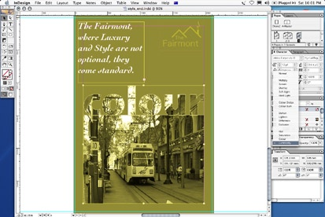
13. And select menu OBJECT>COMPOUND PATHS>MAKE
14. The 2 objects are now one

15. Place Train image into the path
16. Position picture/text fill box at bottom, and apply drop shadow
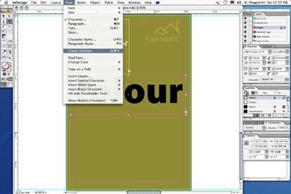
17. Set blending mode to LUMINOSITY

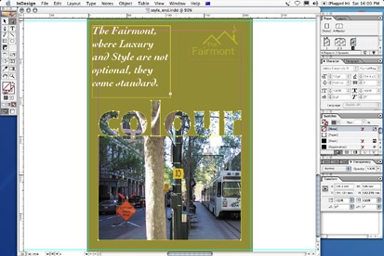
FINISH


Need help just ask

